Volume

1

JAMES COOK UNIVERSITY

Non-Invasive Current Transformer

CT M-3501

User Manual

JAMES COOK UNIVERISTY

CTM-3501 USER MANUAL

© James Cook University

12345 Main Street • Suite 100

Clinton Elliott

Michael Gorgias

Spokane, WA 56503

Phone 203.555.0167 • Fax 203.555.0168

T A B L E O F C O N T E N T S

T A B L E O F C O N T E N T S i

SAFETY 2

PACKAGE CONTENTS 3

1. CTM-3501 Device 3

2. ZigBee 3

3. Raspberry Pie 3

4. Connections Cords 3

HARDWARE INSTALLAION 4

MONITOR SETUP 5

FAQS 6

TECHNICAL INFORMATION 6

INSTALLATION NOTES 6

Nominal Ratings 6

How to Create a Document 6

MORE TEMPLATE TIPS 7

INDEX 7

Chapter

1

INTRODUCTION

We recommend in the installation by a licensed Electrician.

Energy metering and monitoring are at the heart of energy management, understanding when and where your energy is consumed is key to saving money.

To create a drop cap for the lead paragraph, like the example above, select the letter T, and then type a new letter.

Note

For different voltages refer to website www.ctm-3501.com

# SAFETY



The “icon key” at left was produced by using the Heading 8 style for the words “icon key” and the List Bullet 5 style for the text below—which uses a Wingdings symbol for the bullet character. To change the bullet symbol, click **Bullets and Numbering** on the **Format** menu. Click **Modify**, and then click the **Bullet** button. Select a new symbol, and then click **OK** twice.

🗁

The “picture” icons are Wingdings typeface symbols formatted in white with a shaded background. To insert a new symbol, select the character and then click **Symbol** from the **Insert** menu. Select a new symbol, click **Insert**, and then click **Close**. To create new icons, format a one-character paragraph as the Icon 1 style.

To change the shading of the Icon 1 style, click **Borders and Shading** on the **Format** menu. Select a new shade or color, and then click **OK**.

# PACKAGE CONTENTS

Check to ensure all CTM-3501 package contents have arrived:

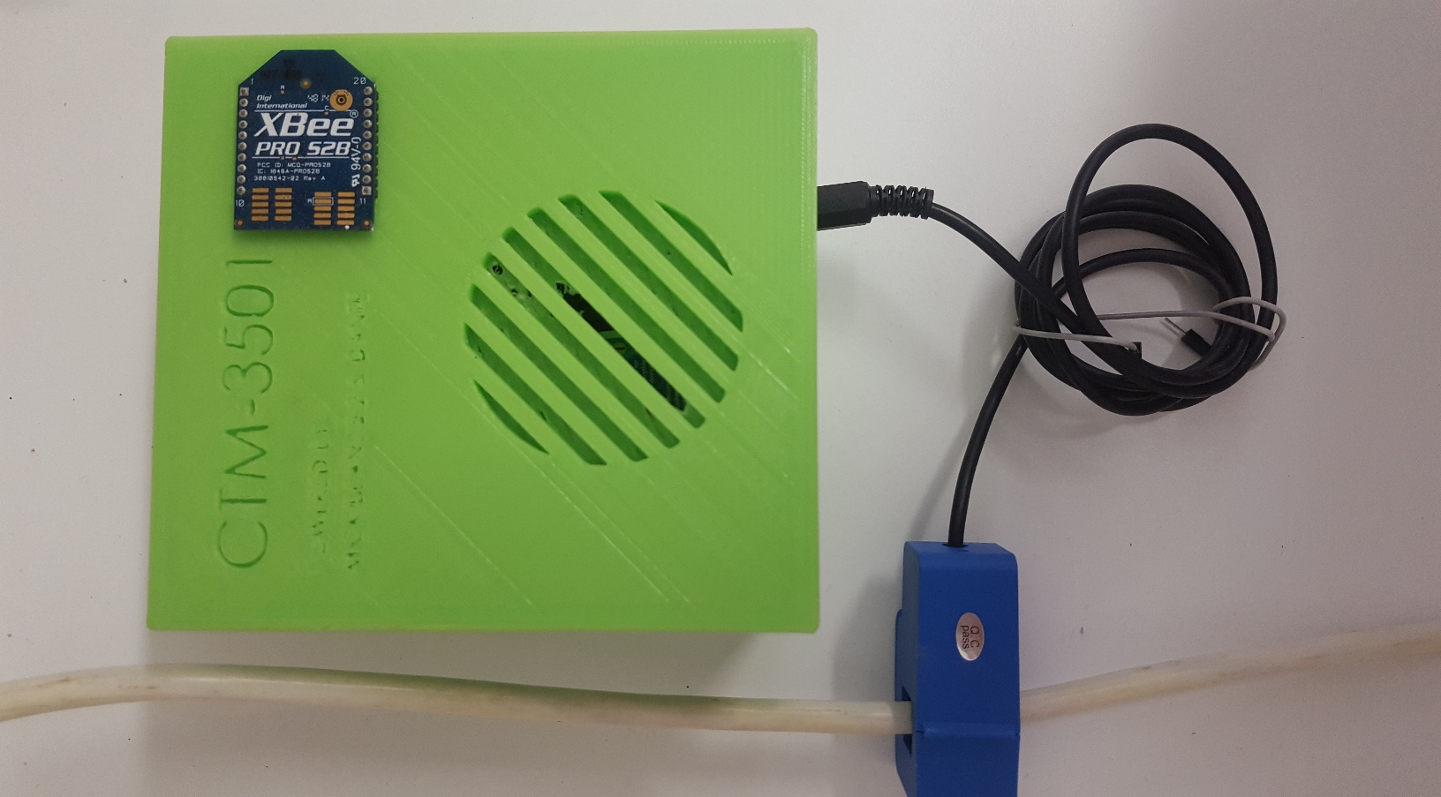

**D**

**B**

**A**

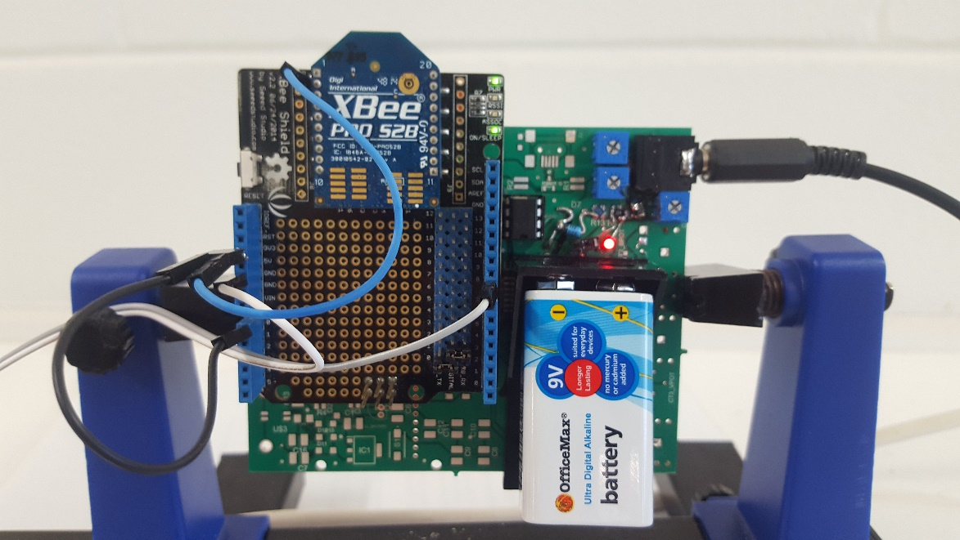

**c**

### CTM-3501 Device

1. 1 x CTM-3501 Case
2. 1 x 10A Current

Transformer

1. 1 x 9V Battery
2. 1 x ZigBee (Coordinator)



Check to ensure all Raspberry Pi package contents have arrived:

### Base Station

1. 1 x Raspberry PI
2. 1 x Power Cable (not shown)
3. 1 x Wi-Pi
4. 1 x Ethernet Cable
5. 1 x Ethernet-USB Adaptor (if required) (not shown)
6. 1 x ZigBee Router
7. 1 x ZigBee Cable
8. 1 x SD Card

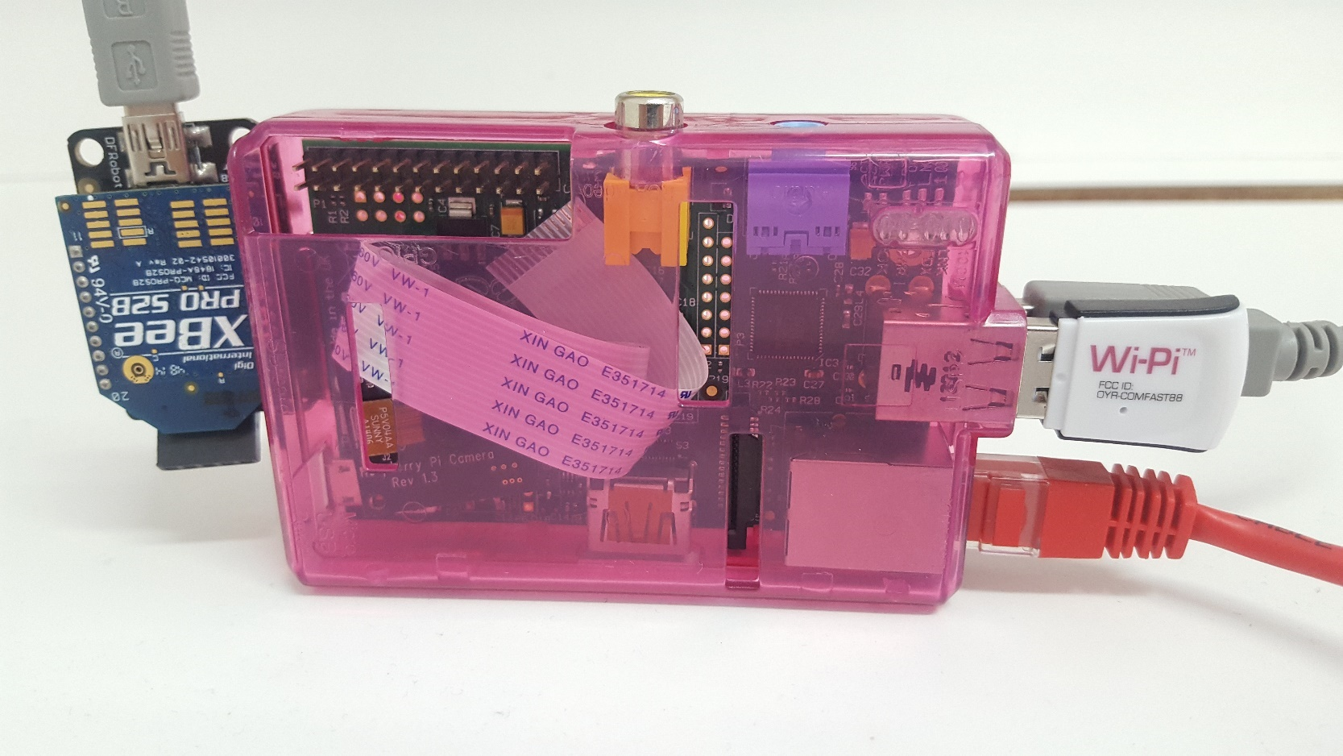

**G**

**C**

**D**

**A**

**F**



Check to ensure that you have adequate devices:

### Viewing Station

1. 1 x Computer (or similar device)
2. 1 x Router Connect to Internet
3. 1 x Installed Putty Program

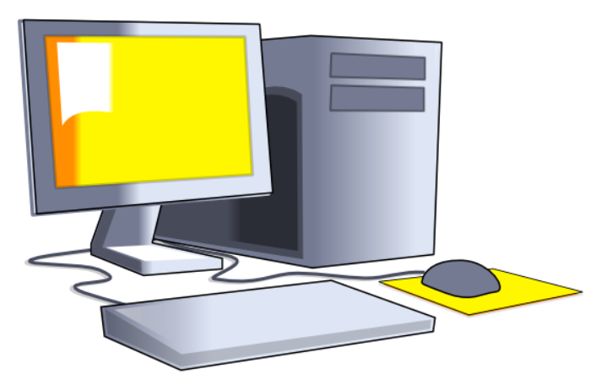

**A**

**B**

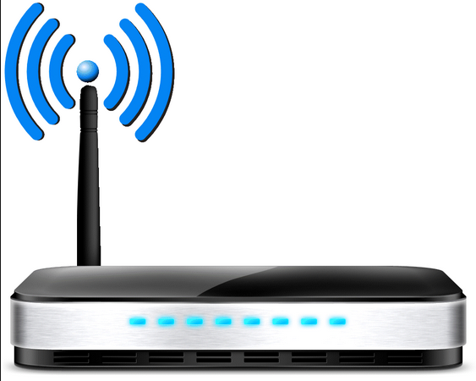

**B**

Note

The CTM-3501 can be routed via hot-spotting on Android

# HARDWARE INSTALLAION

The CTM-3501 is installed by clipping the CT sensors around the feed wires of in your main switchboard. In Australia the standard residential voltage is 240V.

Note

Note - For a 240V panel (typical residential electric panel) power is measured using one CT sensor. For different voltages, please change during the Monitor Setup stage (see website). If in doubt, contact an electrician or other qualified person to assist you with the installation of the mini CT sensor.

1. 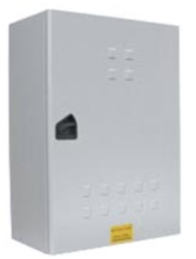Locate Your Meter Box

Locate your electricity meter and determine its type. You

can normally find this on an outside wall, in the garage,

basement or utility room. If you live in a flat, it can often

be found outside your front door, in the communal

stair case, or in the basement. Ensure there is enough

of accessible cable coming from the bottom of your

electricity meter.

1. Connect to Selected Cables

You should find cables exiting the meter, the main feed cable is the live

cable exiting from the meter. Connect the CT sensor to the main cable or to the circuit desired to be measured as shown in the figure.

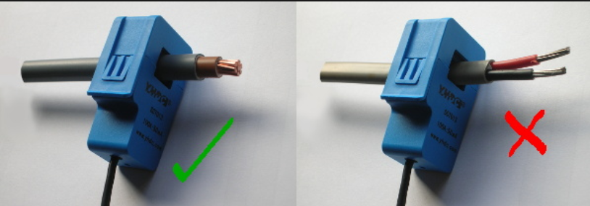

1. 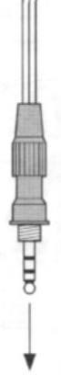Connect CTM-3501 Device

Insert the jack on the end of the CT sensors wire into any of the four input sockets on the CTM-3501 device. The CT sensors acts as a current sensor and relays the current

being drawn on the selected cables to the base station. Mount the CTM-3501 device

on the wall next to or above the meter box and ensure it is in a safe location from movement or the environment. This will make it easier to replace the batteries

(although the batteries will last for a long time). If the panel is in a finished area, you may mount the transmitter inside the meter box. This may reduce transmission distance. Replace the panel cover(s) when finished installing the mini CT sensors.

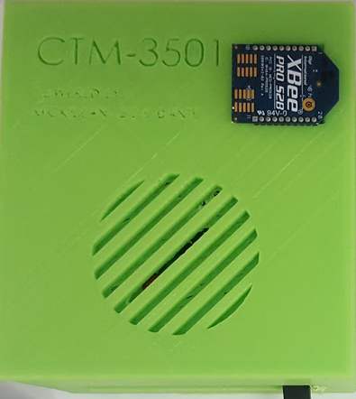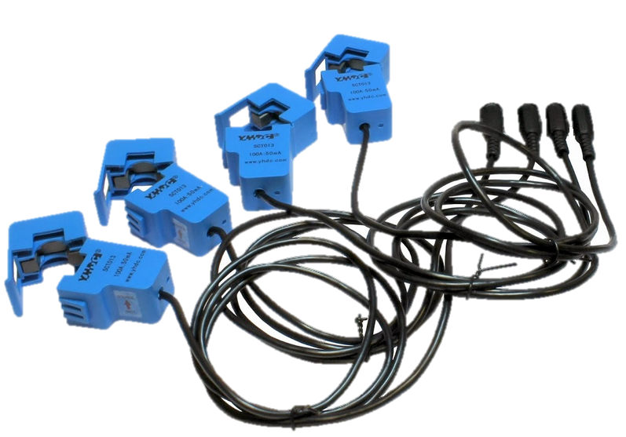

1. Setup Base Station

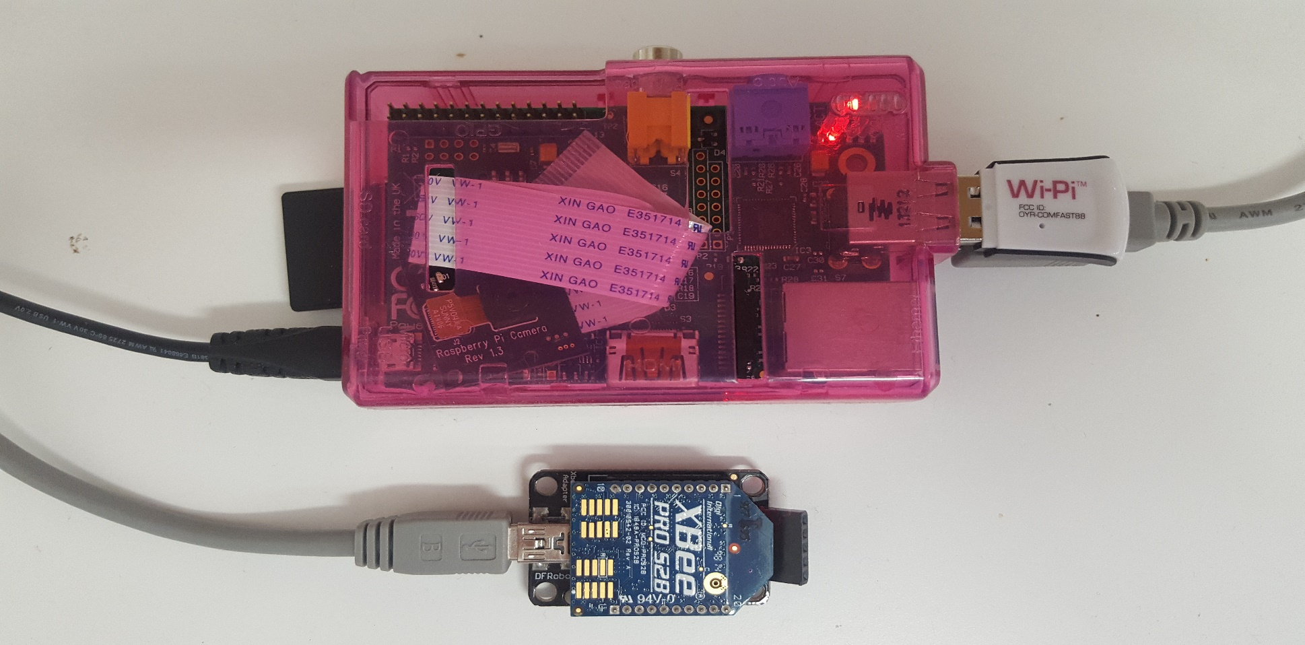

1. Insert the Wi-Pi dongle.
2. Connect the Xbee via its cable to the Raspberry Pi.
3. Connect the power cable to the Raspberry Pi, insert it and switch 230V mains power.
4. Check to ensure the red light turns on.
5. Ensure the SD card is inserted straight.

# MONITOR SETUP



1. Connect computer USB 2.0 to Raspberry Pi via Ethernet (use adaptor if necessary)
2. Open Putty Application
3. Connect to Pi

* Username: pi*
* Password: pi* (default)

1. Connect to internet by entering (if not already connected)
   * Ifdown wlan0*
   * Ifup wlan0*
2. Navigate to Directory

* cd ctpi/build*

1. Run Program

* ./main /dev/ttyUSB0*

1. To Monitor Power go to

* @http://ctm-3501.com/

Note

See troubleshooting for more information about internet connection options. * Must be run at command line Putty window.

# FAQS

In print layout view, double-click the header or footer to activate it, or click **Header and Footer** on the **View** menu. You can change or delete the text just as you would regular document text. To specify placement and whether the header or footer should be different on odd and even pages, or different for the first page only, click **Page Setup** on the **File** menu, and then click the **Layout** tab.

# TECHNICAL INFORMATION

To create a numbered paragraph:

1. In the **Font** list on the **Formatting** toolbar, click the **List Number** style; or
2. Click the **Numbering** button on the **Formatting** toolbar.

If you choose to format more than one paragraph, Word will automatically number the paragraphs.

# INSTALLATION NOTES

## Nominal Ratings

When you save the manual template with your changes, it will be easier to create documents in the future. To customize this manual:

1. Insert your company information in place of the sample text on the cover page, as well as the inside-cover page. If you plan to use styles such as the “Icon Key” or Icon 1 style, set them now (see instructions, page 1).
2. Click **Save As** on the **File** menu. In the dialog box, click **Document Template** in the **Save File as Type** box. (The file name extension should change from .doc to .dot.)

## How to Create a Document

To create a manual from your newly saved template, click **New** on the **File** menu to re-open your template as a document. If you followed the steps above, your company information should appear in place. Now, you are ready to type your manual.

# MORE TEMPLATE TIPS

There are three ways to view the various style names of the template sample text:



1. In normal view, click **Options** on the **Tools** menu. Click the **View** tab. In the **Style Area Width** box, dial a number, and then click **OK**;
2. In any view, click a paragraph and view the style name on the **Formatting** toolbar; or
3. On the **Format** menu, click **Styles and Formatting** to display the **Styles and Formatting** pane.

# INDEX

background, 2

border, 4

bullet, 2

caption, 4

color, 4

drawing, 4

drop cap, 1

footer, 5

frame, 4

graphic, 4

group, 4

header, 5

help, 5

link, 6

margins, 3

normal view, 1

number, 5

picture, 4, 6

print, 1

re-size, 4

section break, 3

shading, 2

style, 1, 3, 4, 6

symbol, 2

Table of Contents, 5

template, 6

ungroup, 4

Wingdings, 2